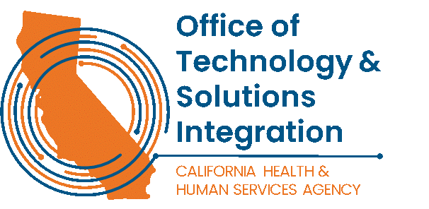

CWDS Infrastructure Team Informational Summary

The Child Welfare Digital Services (CWDS) project supports end-users through technology and aims to ensure the safety, permanency, and well-being of children at risk of abuse, neglect, or exploitation. CWDS is responsible for maintaining and operating the existing Child Welfare Services/Case Management System (CWS/CMS), as well as developing the replacement system, the Child Welfare Services-California Automated Response and Engagement System (CWS-CARES).

CWDS will deliver the Child Welfare Services - California Automated Response and Engagement System (CWS-CARES) using technologies from IBM, Salesforce, and products created exclusively by CWDS. Project partners include social workers from counties, child welfare subject matter experts, and multiple state and federal agencies.

The primary purpose of the infrastructure team which currently supports the 58 counties and tribes within the state who utilize the CWS/CMS Legacy System. The team provides improved maintenance and operations to the project as a whole and leads development of future iterations. The infrastructure team meets regularly with these multidisciplinary team leaders to forge a path forward for the successful transition to deliver and maintain CARES. This team travels on occasion to support the configured equipment to the counties.

The CWDS Infrastructure team supports a wide range of services and activities, such as:
- Manage and maintain both on-premises (LAN/WAN) and cloud infrastructure
- Manage and support Identity and Access Management activities
- Manage and validate access of supported infrastructure, applications, and best practices
- Manage and oversee configuration and asset management / asset replacement
- Manage business intelligence environments (i.e.: Tableau, Business Objects)

The CWDS Infrastructure team consists of both State and Vendor team members. The infrastructure team currently consists of (1) IT Supervisor II, and (6) IT Specialist I state staff. This dynamic team’s unique duties often require staff to lift, pull, stoop, and travel throughout the state to service on site technology. They carry state issued cell phones to support their customers and work non-standard business hours to support their customers on a rotational and technical specialty basis.

Page 1 of 2
Unit Summary
Unit Name: Infrastructure & Operations
Primary Responsibilities:
The Infrastructure & Operations team is responsible for the overall architecture, implementation, management, and optimization of the organization's on-premises and cloud infrastructure. This includes maintaining high levels of uptime, security, and performance across all systems, managing enterprise hardware and software, as well as ensuring operational continuity through robust processes and tools.

Key Focus Areas:
Infrastructure Design & Management:
Design, implement, and maintain scalable, reliable, and secure infrastructure solutions.
Oversee both on-premises and cloud-based systems, including data centers, servers, networking, and storage solutions.

Operational Excellence:
Develop and implement standard operating procedures (SOPs) for infrastructure management.
Drive continuous improvement in operational processes, ensuring efficiency, reliability, and security in daily operations.

Monitoring & Security:
Utilize industry-standard monitoring tools and methodologies to proactively monitor infrastructure performance and security.
Ensure infrastructure security through regular audits, vulnerability assessments, and incident response management.

Cross-Functional Collaboration:
Work closely with other teams (e.g., security, networking, software development) to ensure alignment and effective incident management.
Foster strong relationships with stakeholders and provide technical leadership and support across various projects.

Documentation & Reporting:
Maintain comprehensive technical documentation for infrastructure, including network diagrams, system configurations, and operational procedures.
Provide regular reports on system performance, uptime, and incidents.

Technologies Utilized:
Cloud platforms: AWS, Azure
Monitoring and logging: SPLUNK, MS Sentinel, Zscaler
Networking: Cisco, Palo Alto Networks
Security: Crowdstrike, Armis, IBM BigFix, Palo Alto
Server Management: Windows Server, Linux
Collaboration tools: Jira, Tableau, Mulesoft

Team Characteristics:
Strong technical expertise across multiple platforms and technologies.
Excellent problem-solving and analytical abilities.
Proactive communication and interpersonal skills.
Focus on innovation and continuous learning within the infrastructure domain.
Page 2 of 2

